Give a hand donate blood!

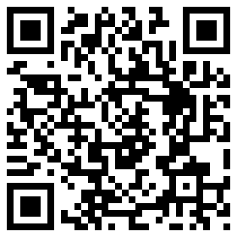

Date and Time: Sunday December 2nd 10:00 -4:00 pm

Location: VBHS Old Gym

2001 E. Pointer Trail

Van Buren, AR

Scan this QR code using your IPhone and using the scan app for more info!! :D

Yadira Ledesma, Aarón Centeno, Alex Coatney